Customer interface
System interface obey some basic principles:
- Give users the choice from a list rather than letting them input by keyboard
- Give enough information when user need them, so that it help users make the decision
- Tell the function clearly before users click a button or link
- Be concise but efficient to help users go on the process
- When an operation is done, there will be a feedback information to tell the user what has been don

Head of all the customer Page
Before login: the content page except the dishes page is not available
After login: on the top right, it comes out the greeting words
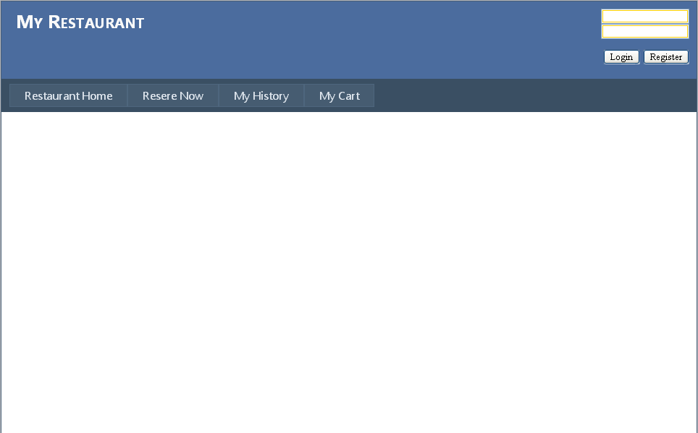

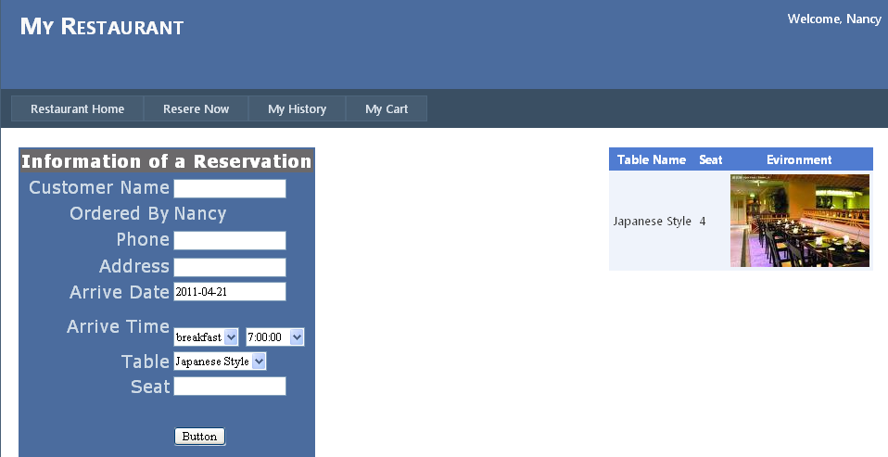

Help customer when they need indication, this function help customer to complete his login name
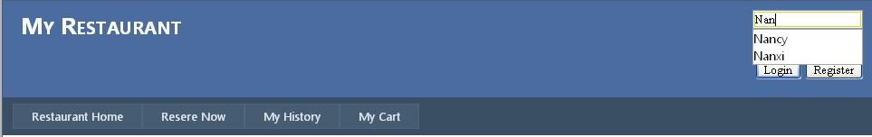

Direct among pages:
A menu helps user to direct to other pages, it will show the list when customers move its mouse over the menu.
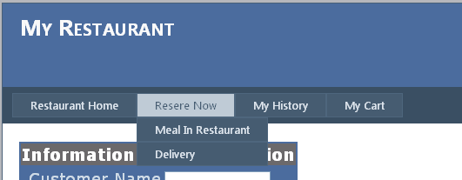

Many content
Back ground clock: light blue and white
Main content in the page is presented as a table and contains the related items in customers request

Register table
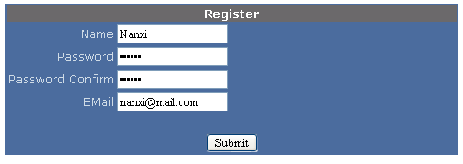

History table
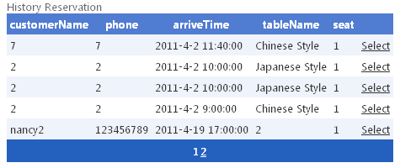
User can get recommended dishes by click the Hot Dish button or input a keyword to search the dishes match.

Customers can click the select button to view the detailed information of the dish, the page will transfer to detailed dish page
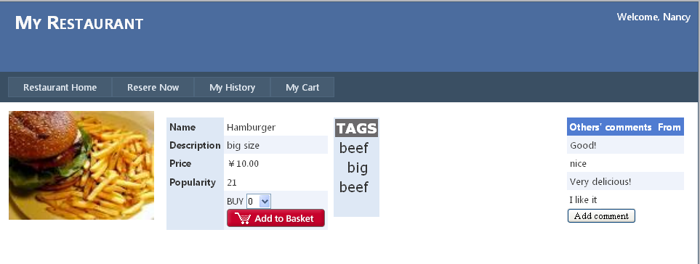
As shown, in this page, the detailed information is presented, including dish picture, price, popularity, others’ comments, and so on.
In this page customer can decide how many dishes he want by selecting an number in dropdown list. Click Add to Cart button will add the dish to the shopping cart.

Feedback information
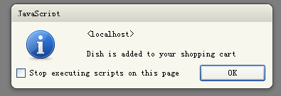

Reservation details:
When user click the Select button of a history reservation the dishes related is presented in the table next to it
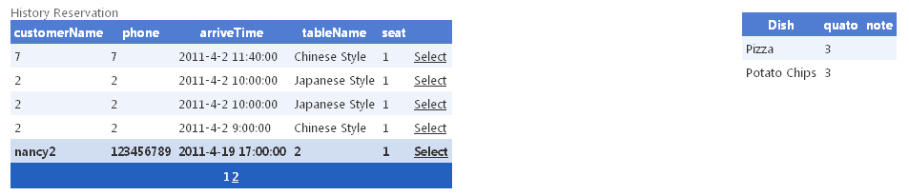

When customer submit a reservation or a delivery, the data, time, table can be chosen in dropdown list, but name, phone, and address need customer input by keyboard
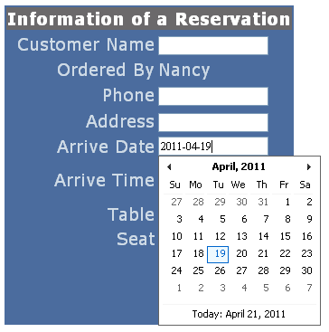

When a table is selected, pictures and detailed information is given to help customers decide whether he likes this position or not.
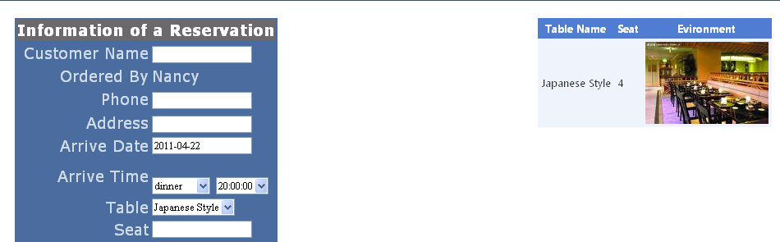

Manager interface
Manager pages is much similar as the customer pages, however the table management need carefully designed.
System use for pictures to specify four tables states
It help manager clearly maintain the state of tables, and when a table is selected, the button available is activated based on its state
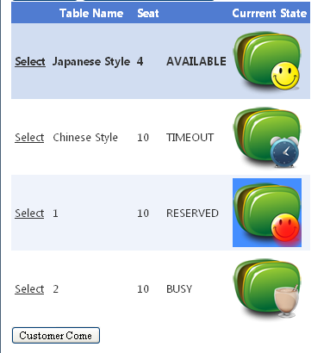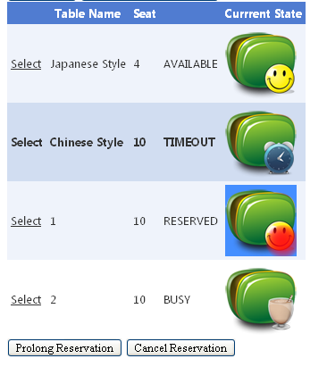

Detailed information about the table is given in another two tables, when a table is selected
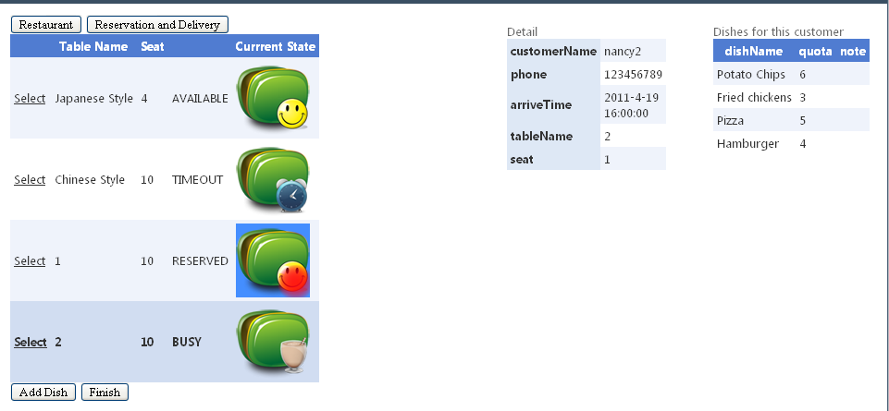

Use red font to remind manager these reservation and delivery are TIMEOUT which need addressed immediately. And manager can decide cancel or prolong the reservation by simply click the corresponding button.
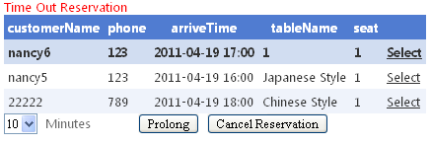
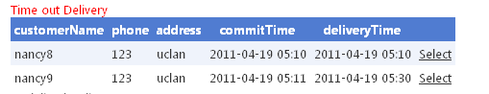

Admin pages
The color of admin pages is red to help remind the admin current profile. It is different from customer profile that in admin profile his operation is greatly affect the system configuration.
